MIXED

Text 1

I. summarize each paragraph in one sentence or phrase

|  |  |
| --- | --- |
| Text | Summary |
| Each year, tens of thousands of lower-income high school and community college students with strong academic credentials do not apply to institutions where they could earn the bachelor’s degree that is a ticket to better careers and higher earnings. Not only are these students hurt by the lack of opportunity, but the country also loses out when talent goes undeveloped and citizens are held back. Consequently, it’s welcome news that some of the nation’s top colleges and universities launched an effort to increase enrollment of these underrepresented students. Even better is that the initiative is showing promising signs of early success. |  |
| Members of the American Talent Initiative (ATI) have increased enrollment of students who receive federal Pell grants by 7,291 since the 2015-2016 school year, according to an ATI report released last month. The gain, while seemingly small, is notable because it reverses a decline in enrollments by low- and moderate-income students in recent years and it puts the ATI on track to reach and even exceed its overall goal. |  |
| What’s been most encouraging is the growth in the ATI from 30 founding members two years ago to 108 schools today. The schools all boast six-year graduation rates of at least 70 percent and include prominent liberal-arts colleges, flagship state universities and every member of the Ivy League. The initiative is backed by money from Bloomberg Philanthropies, but the schools, which commit to the collective goal while also setting individual goals, must raise money for scholarships and programs that support low- and moderate-income students. |  |
| Of key importance is the establishment of socioeconomic diversity as a priority of university leadership. Among the strategies that have proved effective are a shift from merit-based to need-based financial aid and outreach to community college graduates and military veterans. Some schools have increased the size of their student bodies to create additional space for students who receive Pell grants. |  |
| Much work still must be done to bridge the economic chasm that keeps higher education out of reach for too many Americans. So let’s hope the report is right in concluding that the initiative “has shocked members, surfaced and shared effective practices, and raised the profile of socioeconomic diversity, thereby laying a foundation for further progress.” |  |

II. What is the issue?

III. Mind-map

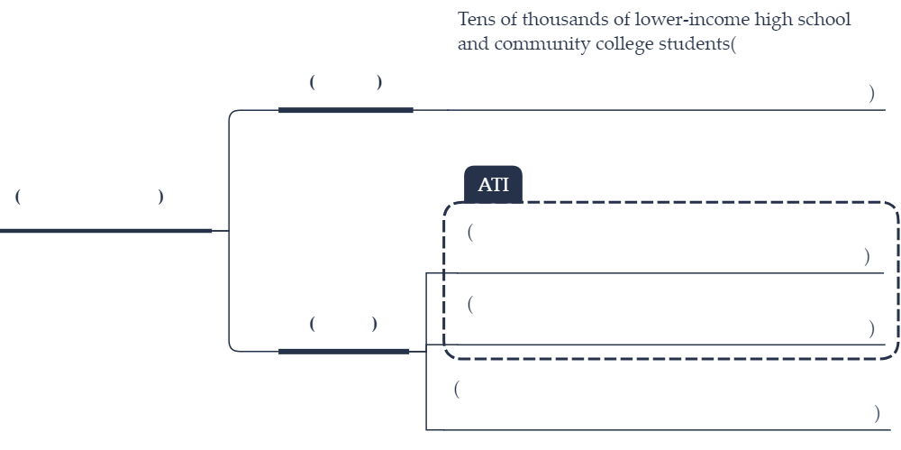

Text 2

I. summarize each paragraph in one sentence or phrase

|  |  |
| --- | --- |
| Text | Summary |
| “MEASURE THE VOID.” That was the mission of student reporters from across the country who spent the past months writing obituaries for every child and adolescent killed by gun violence in the year since the mass shooting at Marjory Stoneman Douglas High School in Parkland, Florida. That they succeeded, and in such heartbreaking detail, should serve as a rebuke to elected officials in Washington and state capitals who failed to enact gun-safety laws that could save lives. |  |
| The extraordinary reporting project, “Since Parkland,” tells the stories of 1,200 young Americans who died as a result of gun violence in the year after the Parkland mass shooting in which 17 people, 14 of them students, were killed. The 200 teenage journalists who helped conceive the project last summer said they were frustrated with media coverage that focused on mass shootings but ignored the continuing gun violence that too many children face every day in their own neighborhoods. |  |
| The students, supported by a nonprofit news outlet devoted to gun violence, and other organizations, recorded lives lost to armed domestic violence, stray bullets, drug homicides, and unintentional shootings. They went beyond the statistics to tell the human stories. Such as: Amauri Green, 16, an “occasionally silly teenager who liked to tell jokes,” who was killed while changing a flat tire. Ke’Anthony Terez Jelks Jr., 2, “so playful, so joyful, [so] fun,” and killed when he mistook his father’s gun for a toy and shot himself in the face. Londyn Faith Strawn, 6, “gymnast, artist, and proud mom of her new puppy, Buttercup,” who was shot to death by her grandfather, along with her mother and grandmother. The list of dead goes on — and it does not even include the estimated 900 to 1,000 young victims of gun suicides. |  |
| And so, once again, the question must be asked: How many more lives must be lost before sensible laws are enacted to combat gun violence? The House Judiciary Committee this week passed a measure that would require background checks for all gun sales and most gun transfers. The action was the most significant gun-control legislation to advance in Congress in years, and its chances for approval in the Democratic-controlled House are good. Pitifully, its prospects are far different in the Republican-controlled Senate. But those who favor sensible gun laws can draw some hope and inspiration from the energy and passion of young people such as those responsible for “Since Parkland” who are determined to write a new ending to America’s story of gun violence. |  |

II. What is the issue?

III. Mind-map



Text 3

I. summarize each paragraph in one sentence or phrase

|  |  |
| --- | --- |
| Text | Summary |
| [Women](https://www.independent.co.uk/topic/women" \t "_blank) who work long hours have a higher risk of depression than men, a new study has found. Researchers at UCL and Queen Mary University of London found women who work more than 55 hours a week had more symptoms of depression than women working a standard 35 to 40 hour week. |  |
| The study of over 20,000 adults found men tended to work longer hours in paid work than women and having children had different impacts on men’s and women’s work patterns. Mothers tended to work fewer hours than women without children, while fathers were likely to work more hours than men without children. |  |
| Gill Weston, lead author of the study, said they were surprised to find that the link with depression is stronger in women. She said: “This is an observational study, so although we cannot establish the exact causes, we do know many women face the additional burden of doing a larger share of domestic labour than men, leading to extensive total work hours, added time pressures and overwhelming responsibilities. |  |
| “Additionally women who work most weekends tend to be concentrated in low-paid service sector jobs, which have been linked to higher levels of depression.” |  |
| The researchers called for greater support for women working long hours at work and noted many also deal with significant pressures at home. Women who worked longer than 55 hours weekly had 7.3 per cent more depressive symptoms, such as feeling worthless or incapable, than women working standard hours. |  |
| Ms Weston, of UCL, said: “There’s a possibility that gender roles may explain some of our results in that women may feel the strain of greater time pressures and responsibilities of combining long or irregular hours of paid work with unpaid domestic and caring duties. Despite the rise of men who take on more domestic responsibilities, men still do less housework and childcare than women. “ |  |
| She said another potential explanation was the fact that men tend to earn more than women, so perhaps men deem long and irregular hours to be worth it.  “One of the theories of job stress explains that when there is an imbalance between the amount of effort a worker puts in, with the rewards and support they get in return, stress arises,” she said. |  |
| Weekend working was linked to a higher risk of depression among both men and women. Women who worked for all or most of the weekend had 4.6 per cent more depressive symptoms on average than women working only weekdays. The study found this figure was 3.4 per cent among men. |  |

II. What is the issue?

III. Mind-map



Text 4

I. summarize each paragraph in one sentence or phrase

|  |  |
| --- | --- |
| Text | Summary |
| At last week’s meeting in San Francisco between Jeremy Wright, the culture secretary, and Mark Zuckerberg, the elusive boss of Facebook. Mr Wright did not willingly share a lot of data afterwards, though who knows what might end up online. He described the talks as “useful”, while Facebook reported a “positive and productive conversation”. |  |
| The fact that a cabinet minister was obliged to travel to California, after Mr Zuckerberg declined repeated invitations to appear before parliament, gives an insight into the relative balance of power as pressure grows to impose a semblance of order, integrity and legality on a chaotic online digital world. By consenting to meet, Mr Zuckerberg gave the impression that he was doing Wright a big favour. |  |
| This sort of untouchable arrogance lies at the heart of the problem. Facebook and similar multinational, multibillion dollar digital companies now have the power to enter, and influence, almost every aspect of modern daily life. Their conduct, or misconduct, has a direct impact on our democracy, politics and wellbeing. |  |
| While there are undoubted benefits, unregulated (or “self-regulated”) global digital platforms can negatively affect the quality and tone of social discourse. They facilitate the spread of disinformation and fake news. The online world has, for many, become an unsafe place where child exploitation, cyber-bullying and sexual and racial harassment flourish. Grievous harms, especially affecting younger people, can be the result, as was the case with Molly Russell, whose family claimed she took her life after viewing material glorifying suicide on Facebook’s Instagram photo-sharing site. |  |
| Mr Wright’s Californian tour, which also involved meetings with Google, Twitter and YouTube, comes as the government prepares a white paper with legislative and non-legislative proposals for tackling online risks. Mr Wright says he believes government regulation is necessary. “It is clear that things need to change. With power comes responsibility and the time has come for the tech companies to be properly accountable,” he said last week. |  |
| Two key questions demand answers. One is whether any government action will be undertaken with the necessary degree of urgency. To date, ministers, Mr Wright included, have been slow, to the point of irresponsibility, in recognising the immediacy and scale of the problem. It has been rightly pointed out that, if a general election were to be called today, the process would be open to online manipulation, by domestic and foreign influences, including the 2016 Brexit referendum and US elections. |  |
| A second pressing concern is whether any new regulations will be sufficiently robust and wide-ranging to decisively change the behaviour of powerful businesses such as Facebook and, say, reduce opportunities for online disruption by ill-disposed foreign governments. Ministers are rightly focused on social harms. They appear to be less enthusiastic about tackling overtly political issues such as past and present pro-Brexit disinformation, data theft for commercial purposes, and online privacy abuses. |  |

II. What is the issue?

III. Mind-map

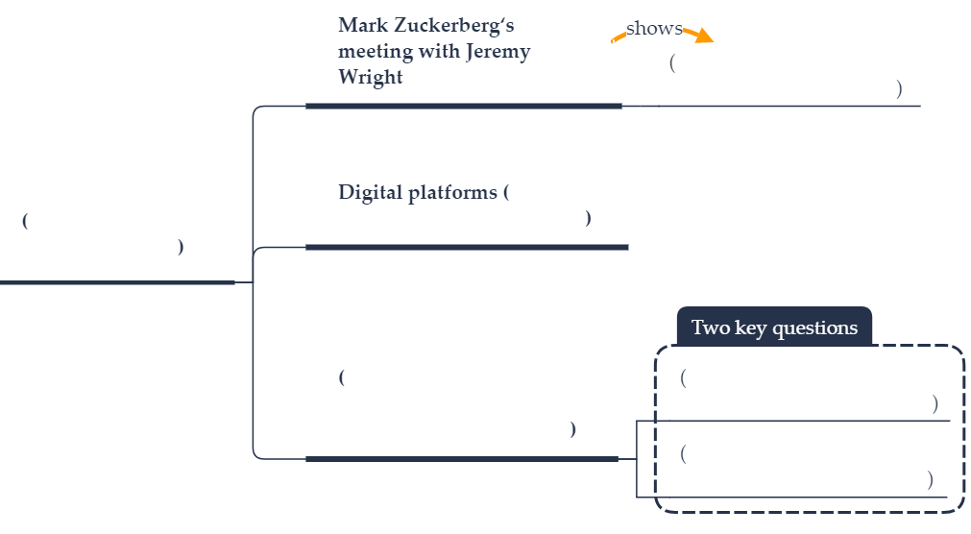

Text 5

I. summarize each paragraph in one sentence or phrase

|  |  |
| --- | --- |
| Text | Summary |
| Teachers will follow on the heels of striking students on Friday with a protest to demand the national curriculum be reformed to make the climate and ecological crisis an educational priority. The Extinction Rebellion group will support the demonstration outside the Department for Education, which organisers describe as a “peaceful nonviolent protest that may involve civil disobedience”. It is intended as a show of solidarity for pupils who skipped classes last Friday to express their frustration at the failure of older generations to adequately address climate change. Organisers said more than 10,000 young people in at least 60 towns and cities in the UK joined the strike. |  |
| More would be likely to follow, they said, if the government did not live up to a Paris climate agreement promise to enhance climate change education. Instead, they say, there is currently no requirement for children to be taught about the climate crisis so it is treated, at best, as a peripheral subtopic of subjects like geography and science. |  |
| They are also unhappy that part of the curriculum appears to cast doubt on the evidence for man-made climate change, even though governments, the UN and the overwhelming majority of scientists accept that it is happening. Government guidelines for key stage 4 chemistry say pupils should be taught “evidence, and uncertainties in evidence, for additional human causes of climate change”. |  |
| Tim Jones, a secondary school teacher from Lewisham, said students in the state system could easily go through 11 years of compulsory education and hear climate change mentioned in fewer than 10 lessons out of approximately 10,000. Given the scale of the crisis, he believes this is “negligent”. |  |
| Earlier this month, the group Teachers for Climate Truth wrote to the DfE to request an overhaul of the current curriculum to prepare children for a future that will be shaped by ecological and climate crisis. |  |
| The government said the current curriculum already included many related issues including classes on seasonal changes, the water cycle, the carbon cycle, eco-systems, the composition of the atmosphere and the impact of carbon dioxide on the climate. “Children are very engaged, otherwise they would not be joining protests. That shows they are obviously being taught quite well,” said a government official. |  |
| Friday’s demonstration is expected to draw between 100 and 200 teachers and academics, most of whom are on half-term holiday. Organisers are also in talks with unions to discuss how to increase support during the next global youth climate strike on 15 March, with possibilities ranging from a walkout by teachers to the setting of homework on climate topics. Extinction Rebellion will also offer workshops for students. |  |

II. What is the issue?

III. Mind-map

